4-8
Travel is one of my absolute passions, as you well know. The current situation is frustrating to me in a very selfish way; I want to plan and research trips for 2020 and 2021. I don’t know when restrictions will ease up so that I can visit Rob in Chicago or experience a new European country. Those of you who have relatives in other countries probably wonder when you can visit them or have them visit you next. It’s frustrating and sad and life-changing. We will get back to normal…eventually.
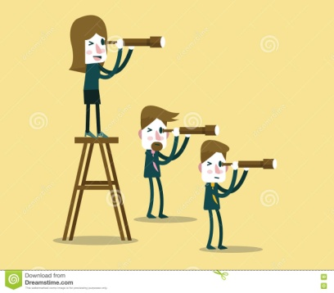
ELA I’m always encouraging you to look for different points of view and perspectives. Let’s do that with “Broken Chain”. Assume the persona of Alfonso, Ernie, Sandra, Frankie, Raul, Raymundo, or Alfonso’s parents. How would each of these tell the story? What unique insight might they have? What opinions would they have about the events and decisions made in the story? If we performed this as a readers theater, which character would you choose to play? Which character(s) can you relate to and why?
Look at the Plot Diagram on page 18. This looks different from the traditional plot pyramid. Think about how you would complete this diagram. Does this kind of graphic organizer help you to understand the plot of a story?
SUPPLEMENTAL READING Celebrate! Today is National Empanada Day and also National Zoo Lovers Day. Empanadas originated in Spain and Portugal; research how to make them and the best Detroit spots for empanadas. Our Detroit Zoo is, of course, closed. Visit https://detroitzoo.org/ to take a virtual zoo field trip.

