4-6
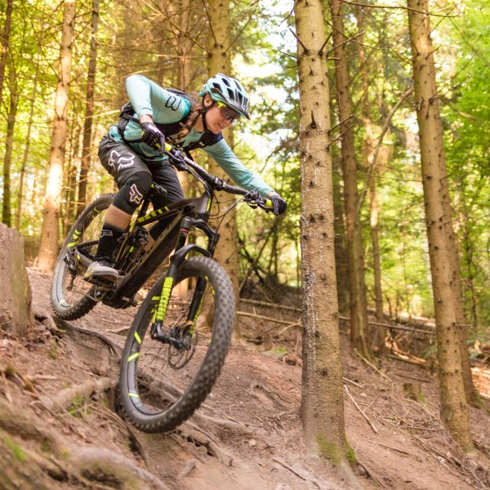
In a normal world, I would be on a plane to Charleston, South Carolina, today for spring break. I had planned to soak up the beauty and history of this classic southern city. Instead, I am soaking up the beauty and history of…my recliner
Today’s reading focuses on a bicycle. Do you have a bike? Have you been riding it lately? Try to get out daily and cruise around the neighborhood. It will clear your head AND give you some physical activity.
ELA Let’s read the first half of a short story by Gary Soto. Last week we read his memoir “One Last Time”. When an author draws upon his/her childhood for inspiration, the words and events sound authentic. “Broken Chain” is a short story, but what elements do you think might actually be experiences Gary Soto remembers from his early years? Read pages 6-11. Pay attention to the vocabulary and guided reading questions in the margins. As always, try to make text-to-self connections.
https://www.tesd.net/cms/lib/PA01001259/Centricity/Domain/542/Broken%20Chain%20by%20Gary%20Soto.pdf

SUPPLEMENTAL READING Let’s stick with Gary Soto; look on page 4 of today’s reading. Read about conflict, both external and internal. Think about your experiences over the past 3 weeks. What external conflicts did you encounter? Did you have conflicts with parents? Siblings? Friends? What internal conflicts did you experience? Did you have an “inner debate” with yourself about anything? Did the little angel on your left shoulder and the little devil on your right shoulder go a little crazy? What percentage of your daily conflicts is external? Internal? Do conflicts make life more interesting?

