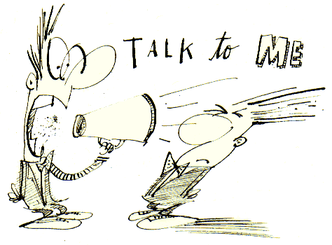
4-3
I’m curious to see who is visiting my lesson plans on Weebly. Would you please send me a quick email today? kiefern@melnapschools.com
I have heard from Madison, Jose, Kyle D., Emmanuel, Mariam, Nadia, and Jayden.

ELA Let’s backtrack and learn about the week’s author, Gary Soto. Read the biographical notes on page 839. This is such a classic American story of rags to riches. Soto could have just accepted the status quo and not challenged himself to break out of the family pattern. What words describe him? Proud? Determined? Resilient? What others can you think of? If you could travel to Berkeley, California, today and meet him, what would you ask him? What could you learn from him? Go to this website to see Soto at the museum established in his honor in his home town of Fresno. Also on page 839, you’ll find thought-provoking discussion of author’s purpose, sensory details, and vocab.
https://abc30.com/amp/community-events/acclaimed-poet-author-gary-soto-leads-tours-at-self-titled-museum-/4641323/

SUPPLEMENTAL READING Earlier this year, we researched different museums in Michigan. Today, let’s build on the 3-30 posted lesson and today’s video about Gary Soto’s museum and visit some other California museums.
http://www.visitcalifornia.com/now/14-must-see-california-museums
https://www.timeout.com/los-angeles/attractions/essential-museums-to-visit-in-los-angeles

