4-15
Everywhere I look, when I am out on my 3-times-a-day walks, I see signs of spring. I spot robins building nests, bulb flowers (hyacinths and daffodils) blooming, trees with buds and blossoms, lawns greening up, etc. Don’t ignore these hopeful signs that life goes on, that hope is on the horizon, that we will survive this crazy turbulence.

ELA We’ve now read one memoir and three short stories by Gary Soto. Let’s wrap this up with a look at two of his poems. Go to:
https://poetryforchildren.blogspot.com/2008/09/celebrate-soto-and-mora-for-latino.html
Read the introductory information about what motivates Soto. Then read the two poems: one from a teen-aged girl’s perspective and one from a teen-aged boy’s perspective. It sounds as if he really understands how 13 and 14 year-old’s think! Remember how his short stories contained boys trying to impress girls. He describes some of the very real issues challenging all teens.

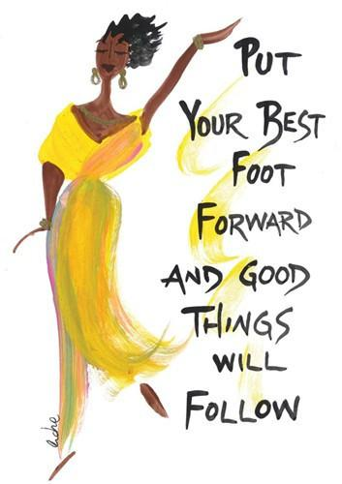
SUPPLEMENTAL READING Write a free verse poem about a time when YOU tried to impress someone. It could be a romantic interest, or it could be a teacher or coach or potential employer. Notice the idiom?
Free verse poems
- Don’t rhyme
- Lines can be different lengths
- Cap/punc is up to you, the poet

