4-13
Try something new! I just bought a new laptop because my 10-year old antique wouldn’t support Zoom. You know how super low tech I am…this is huge! I am completely outside my comfort zone. Push yourself to venture outside your own sense of security, be creative, use this down time to add a new dimension to your daily life.

ELA We’ve read 3 selections by Gary Soto: “One Last Time”, “Broken Chain”, and “Seventh Grade”. Let’ read one more this week: “La Bamba”. Before you read, listen to the song that inspires this story, “La Bamba” by Ritchie Valens, or watch the 1987 biographical film about Valens also called “La Bamba”.
https://www.alvinisd.net/cms/lib/TX01001897/Centricity/Domain/3674/La-Bamba-ST.pdf

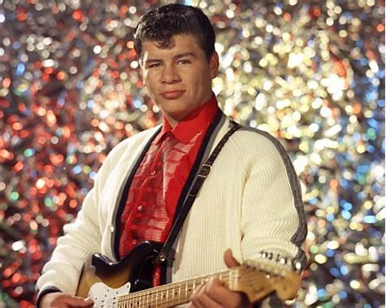
SUPPLEMENTAL READING Learn a little more about the musician mentioned above: Ritchie Valens. (I was 8 years old when “La Bamba” became a hit!) What was his background? Besides “La Bamba”, what other songs made him famous? Did he always perform alone? Where and when was he born and where and when did he die? Listen to some of his other songs. Are you musical? How many hours a day do you listen to your favorite tunes?

