4-1
It’s April Fools Day! Play a few harmless tricks on family and friends today! We all need a good laugh. Are you following the photos being posted on Strong’s Facebook page? Think about sending a Spirit Week contribution to Ms. Elliott.
ELA On line 114 (page 844), Gary Soto talks about spending his hard-earned money on school clothes. When have you worked/saved for something special? What was it? How long did it take to save the necessary funds? On line 119, he says that he picked grapes until he was 15; on line 135 he is 16. He and his brother switch to picking cotton. Read and think about how the two picking experiences are the same and different. Soto doesn’t glamorize either of these two jobs. They are dirty, back-breaking jobs. On page 845, the side note calls your attention to the similes Soto uses in his descriptions, such as “the dust and sand…whipping about like irate wasps”.
SUPPLEMENTAL READING Write similes about your long days at home in this crisis. (Reminder: Similes are comparisons of two unlike things using like or as.)
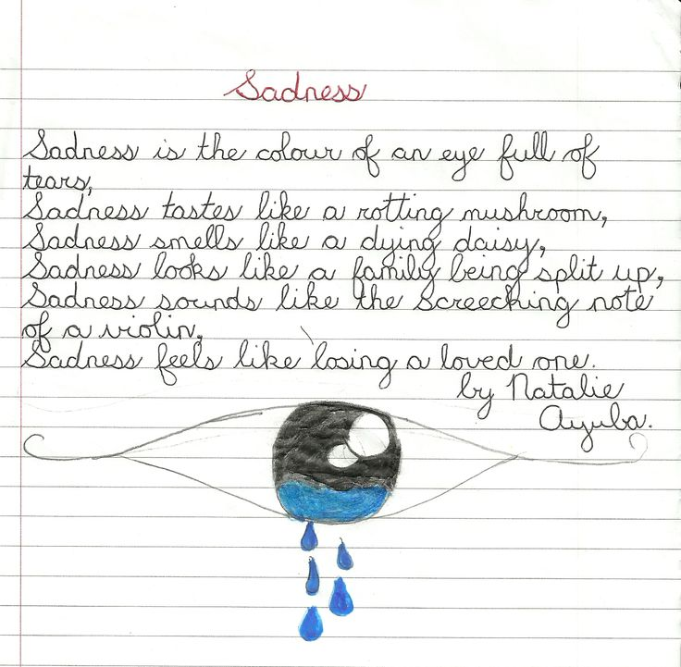
- When I don’t have to jump up with an alarm clock, I am as happy as a robin finding a juicy worm.
- Without my wonderful 8th graders ,
I’m as sad as a worm caught by a robin.
- Taking long walks each day is like visiting a therapist; I feel very zen after!
Look at this poem I found. Natalie uses her 5 senses to write a simile poem.

