3-27
It’s Friday; usually I’d have my pom pom out, right?! What a challenging couple of weeks. I hope you have not just survived but thrived during our time off. Expand your mind, exercise your body, stay connected with important people from a distance, and stay positive.
I hope when I get my weekly Khan Academy report that more of you are taking advantage of this great opportunity!
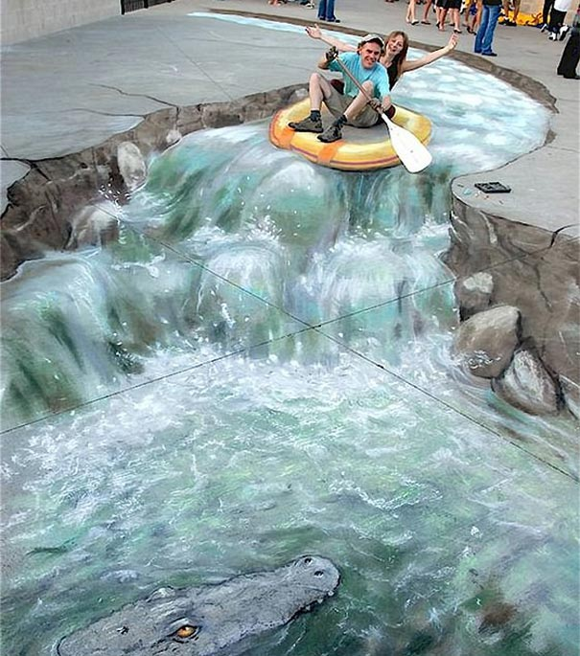
ELA We read and discussed 5 short readings about transitioning to adulthood. None of them addressed marriage and parenthood. Do you see yourself married with children? What about marriage looks like a positive to you? A negative? At what age do you see yourself getting married? Do you have good role models in your family? What about parenthood? What does parenthood look like to you? What makes a good parent? Do you have good parental role models in your family? Have you ever said “I’ll never do that when I’m a parent” or “I will absolutely act like that when I’m a parent”?

SUPPLEMENTAL READING Just for fun, Google 3-D chalk art. What a unique “eye” these artists have! Here’s a video that blows my mind! https://www.youtube.com/watch?v=uzNVo8NbpPI

You can never get too much of the Beatles! Look at this video of 2 young doctors singing John Lennon’s “Imagine”. https://abcnews.go.com/US/doctors-story-viral-rendition-john-lennons-imagine-music/story?id=69776

