3-25
Read…a…good…book! You have no excuses; you certainly have the time! It’s been out for a couple of years, but I am finally reading Michelle Obama’s autobiography Becoming. Read for at least 30 minutes each day. FYI the Taylor library on Pardee has curbside service. You call ahead, give the librarian your title, she locates the book, you pick it up curbside.
Speaking of 30 minutes each day…don’t forget Khan Academy.

ELA The 4th reading in the “Adulthood” selection is “A Parent’s Role in the Path to Adulthood”. This article deals primarily with college students, but we can find parallels to your life. How many of you think your parents are TOO involved in your daily lives? Not involved enough? What would be the perfect balance? As you think about the move to the high school, does your attitude change? Do you anticipate your parents becoming more or less active in your life? Do you feel that you receive good advice from your parents? Do you feel that they are overly protective? Are they “helicopter parents”?

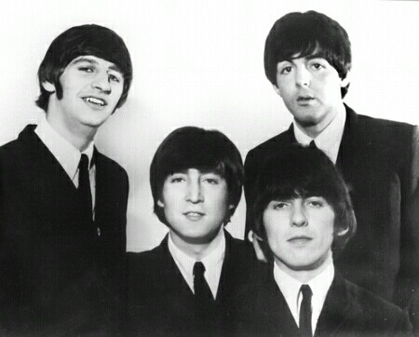
SUPPLEMENTAL READING Let’s research one of the musical groups I recommended yesterday: the Beatles. I was your age in 1964 when the Beatles made their first US appearance. Listen to a couple of their greatest hits, such as “Here Comes the Sun”, “Hey, Jude”, “Let it Be”, and “Come Together”.

https://www.biography.com/news/how-the-beatles-formed

