3-24
Feeling down? How about some songs that are guaranteed to lift your mood?
Some of my faves: “Underdog” by Alicia Keys, “Rise Up” by Andra Day, “Happy” by Pharrell, “Can’t Stop the Feeling” by Justin Timberlake, “You are the Sunshine of My Life” by Stevie Wonder, “Good Day Sunshine” by the Beatles, “Shake it Off” by Taylor Swift
I dare you to keep a frown on your face if you listen to even one of these tunes!
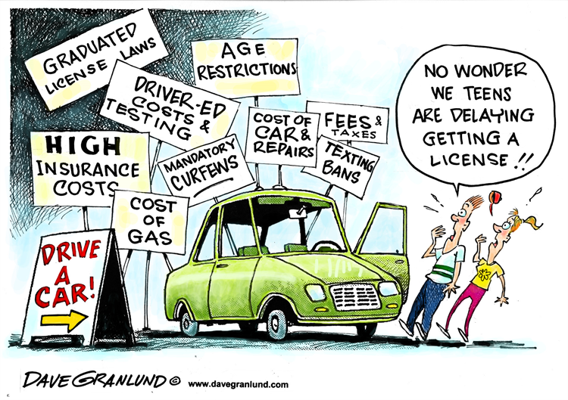
ELA The 3rd reading in the “When Do Kids Become Adults?” selection is “We Need Better Training and More Rules for New Drivers”. I remember how anxiously Rob anticipated taking drivers training, getting his permit, getting his license, and inheriting his dad’s used Ford Contour. I remember how anxiously I also faced those milestones. We got through it all without issue. He has now lived in Chicago for 13 years without a car and doesn’t miss driving at all. Perspectives change! How close are you to taking some of these steps toward adulthood? What are your thoughts about driving? Will you have access to a vehicle on a regular basis? Will you be responsible for getting yourself and maybe siblings to school/work? Who will pay all your vehicle-related costs?

SUPPLEMENTAL READING Let’s build on my musical recommendations. What are some songs or who are some artists that are your go-to’s when you are feeling blue? (There’s an idiom, right guys?! Don’t you dare say “what’s an idiom?”) What are some songs that pump you up before an athletic competition? What are some songs that calm you down when you are anxious?

