3-23
I just looked at the Khan Academy reports for the previous 7 days. I am happy that 17 of you practiced for at least 30 minutes (reading and/or math). Set a goal that you will practice 30 minutes EACH for reading and math this week.
I found an article that has ideas for your creative side. Famous illustrators are providing tutorials online for those who like to doodle, draw, scribble, whatever! https://www.nytimes.com/2020/03/20/books/writers-entertain-kids-virus.html
On my morning walk, I listened to a 45-minute podcast on Freakonomics. If you are interested in current events and topics and how they interface with economics, look at their listings. Here are a couple you might enjoy:
- “Is Learning a Foreign Language Really Worth It?” (Episode 158)
- “How to Be Creative” (Episode 354)
- “People Aren’t Dumb. The World is Hard” (Episode 340)

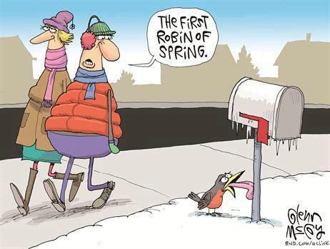
ELA The second reading “Leave the Voting Age Alone” from Thursday’s list discusses the history of teens voting in the US. If you were able to vote for President in November, what would you be doing NOW to make sure you were prepared to make an informed choice? Do you watch any news channels? Do you listen to radio news programs? Do you visit any newspaper or news magazine websites? Do you and your family discuss politics? Would you volunteer to work for a candidate or party?
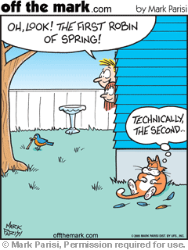
SUPPLEMENTAL READING Here are 2 cartoons about robins and spring. Can you create one? Use your unique sense of humor to design one that celebrates the robin and its special place in pop culture. As I look out the window at snowflakes this morning, I hope the robins can find temporary shelter!

